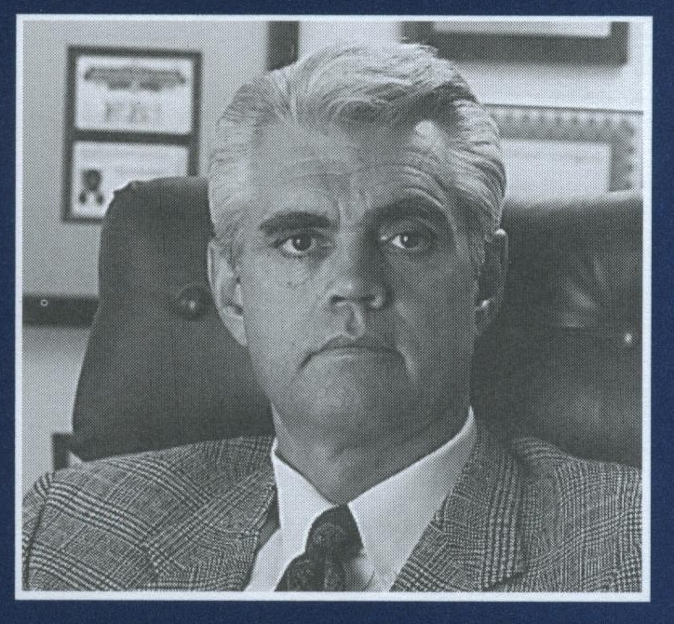  Charles P. Stephenson  Former FBI Agent  President  The Orion Group  Orion Security Inc.  Managing Partner  Midwest Security Guards LLC  www.kcdetective.com  www.kcguards.com  www.alcops.com | THE ORION BULLET  A Professional Security Publication
July 28, 2026
  Forth Orion Group Services:  Civil/Criminal Investigations  Risk management Evaluations  Litigation Support Services  Expert Witness Testimony,  Federal/State Certified:  Public and Contract Security Officers:  *Inadequate Security  *Lack of Planning and Implementation  * Inappropriate and or Excessive use of Force  *Firearms Use and training  Executive Protection/Firearms  Training/State Certified  Carry Concealed Handgun  Video Surveillance Systems  Contract Security Guards  Mobile Patrol/Cash Courier  Neighborhood Watch Programs  Pre-Employment/Background Investigations  Employee Performance  Audits/Mystery Shopping    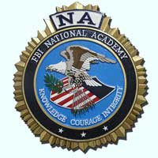       | USE OF FORCE  Considerations  Lethal/Less Lethal  Contract Security Officer Private Detective  Kansas/Missouri  Use of force issues involving lethal/less lethal methods by Law Enforcement Officer Officers continue to be spotlighted by the news media on an almost daily basis. Those incidents continue to be examined for their justification and reasonableness under standards set forth in US Supreme Court  case decisions Graham Vs Conner and Chew Versus Gates. These standards are normally applied to on duty sworn law enforcement officers involved in making an arrest and or defending them self against bodily harm while in the performance of their duties.  Unlike the on duty Law Enforcement Officer, use of force issues involving a Contract Security Officer or Private Detective will be determined by the totality of the circumstance, judicial interpretation of the criminal statue code and results of a civil tort action.  In both circumstances the justification for use of force and reasonable application of that force will be will be determined by the individuals involved and the totality of the circumstance.  For Contract Security Officers and Private Detectives the essential element to be considered, away from the physical incident itself is determining under what legal authority/capacity was the individual and or /agency operating under.  If applicable were they licensed in accordance within the venue and circumstance were the incident occurred.  Accordingly all law enforcement agencies and reputable contract security firms have developed policies and procedures to address use of force.  When contracting for security services expectations for the lawful use of force by the contract security officer must be carefully considered by both parties.  This is best accomplished by contractual agreement and clearly defined post watch orders that clearly define the duties and expectations of the contract security force.  References :  Graham V. Conner,490 U.S. 386, 396,104 L.Ed.2d 443,109 S. Ct 1865(1989)  Chew V. Gates, 27 F. 3d 1432(9th cir.  1994).cert. denied, 513 U.S. 1148, 115 S.Ct. 1097, 130 L.Ed.2nd d1065 (1995).

